

**Topic: Change History and Compare**

One of your job responsibilities is to make sure you review and understand changes to processes and documentation that you use.

When you click the information icon , theSource will provide you with [two features](TSRC-PROD-000828):

1. **Change History** is a summary of the changes that were most recently made to the document. This helps you to understand the changes and where in the document the changes were made.
2. The **Compare to current version** feature will show you a markup of the current document version compared to the last, similar to track changes in Microsoft Word. This can help you better understand extensive changes to the document.

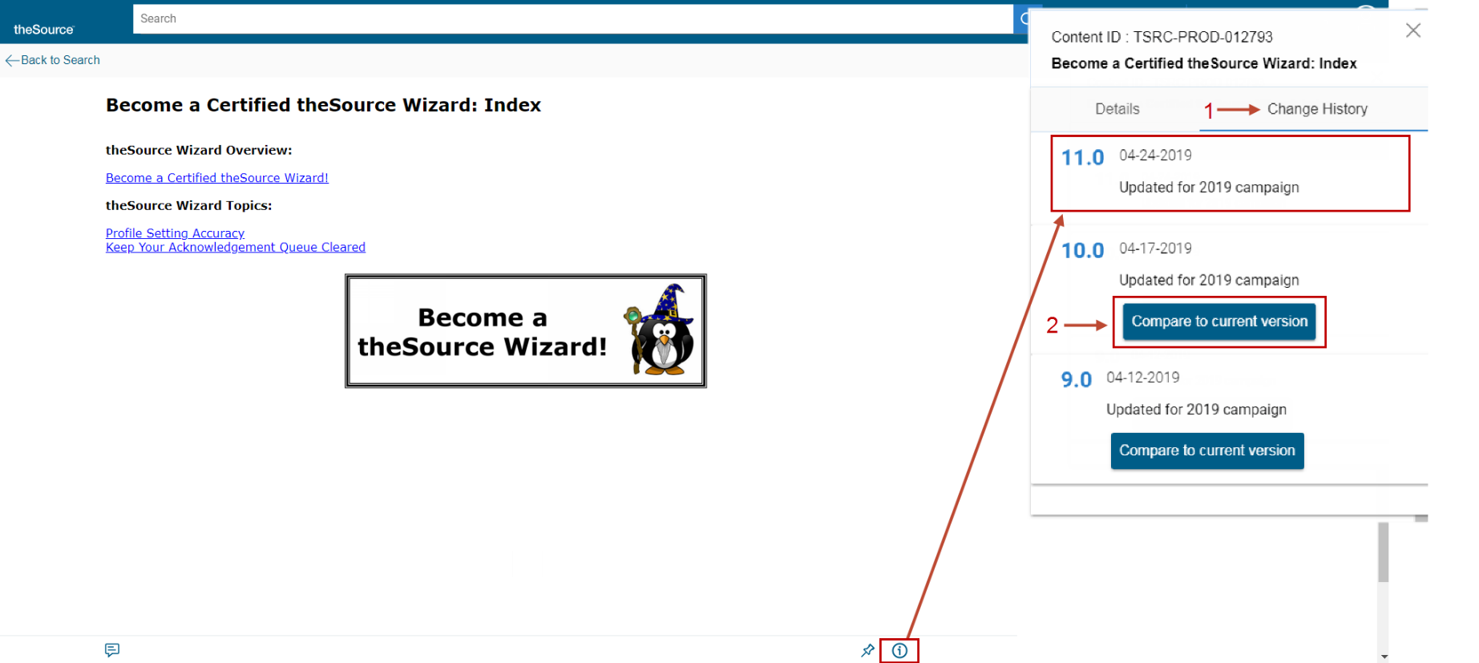

 Your next challenge on the quest to becoming a Certified theSource Wizard is to view the Change History on every document that you Acknowledge. Compare to the current version to have a clear picture of the changes.

Not to Be Reproduced or Disclosed to Others without Prior Written Approval

**ELECTRONIC DATA = OFFICIAL VERSION / PAPER COPY = INFORMATIONAL ONLY**